- What is Langchain and what is Langgraph?

Langchain

LangChain is an open-source orchestration framework launched in October 2022 that simplifies building applications powered by large language models (LLMs). It is available in Python and JavaScript.

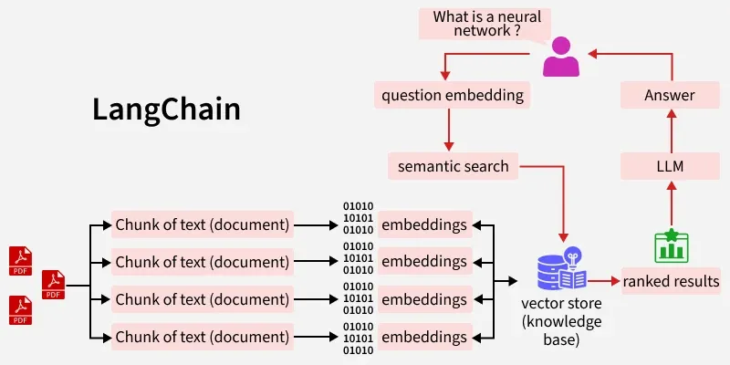

Key Components
- Models & Integration: Connects seamlessly with various LLMs (such as OpenAI, Google Gemini, and open-source models) through a unified interface.
- Chains: Links multiple steps together—such as formatting a prompt, calling a model, and parsing the output—into reusable workflows.
- Prompt Management: Standardizes and organizes prompt templates to control model inputs and outputs.
- Memory: Retains conversation history and context across interactions.
- Retrievers & Vector Databases: Facilitates Retrieval-Augmented Generation (RAG) by connecting LLMs to external data sources, documents, and vector stores.
- Agents: Uses LLMs to dynamically reason, plan, and choose which tools or APIs to call to complete complex tasks.

Langgraph

LangGraph is an open-source orchestration framework built by the LangChain team designed to build and manage stateful, multi-agent, and complex AI workflows using graph-based structures

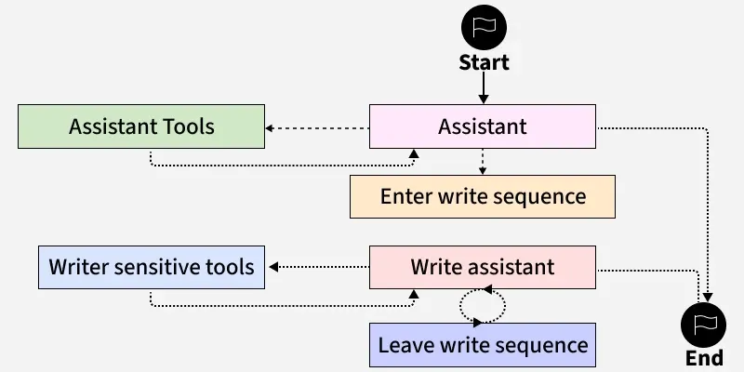

How It Works
Instead of forcing AI applications into a rigid, linear step-by-step pipeline (like traditional LangChain chains), LangGraph models workflows as a state machine graph:
- Nodes: Individual units of work—such as calling a large language model (LLM), running a Python function, executing a search tool, or pausing for human review.
- Edges: Rules, logic, or conditional paths that determine how and when information flows from one node to the next (allowing loops, branching, and parallel processing).
- Shared State: A central memory object that every node reads from and updates, ensuring context is preserved across long-running tasks or multi-agent handoffs.

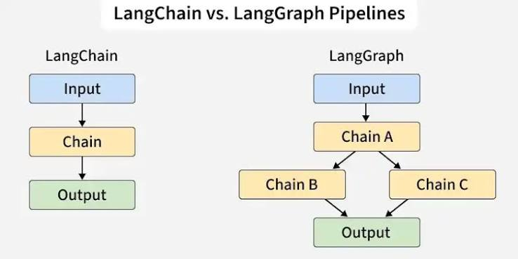
- Agent Lifecycle
The Agent AI Lifecycle (often called the Agent Development Lifecycle or ADLC) describes how organizations plan, build, test, deploy, and govern autonomous AI agents. Unlike traditional software development (SDLC)—which relies on static, deterministic code paths—agents interpret goals, make decisions, use tools, and interact with probabilistic language models.
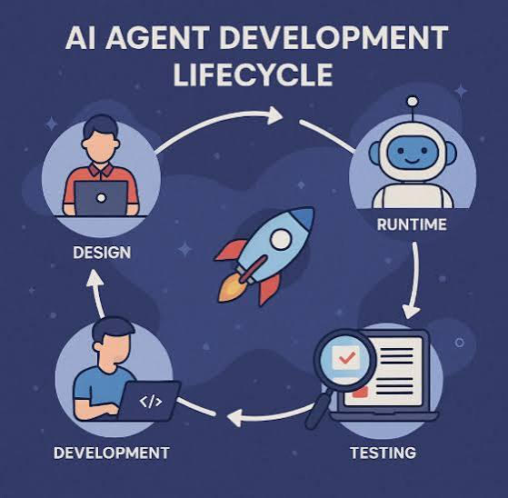
Core Phases of the Agent Lifecycle

1.Problem Framing: Identify Purpose and Scope
AI agents aren’t general-purpose chatbots — they are systems built for targeted, high-value tasks.
- Start with specificity: Define the agent’s purpose: Is it an Investment Assistant? A Debugging Copilot? A Compliance Watchdog?
- Assess complexity and value: Is the task repetitive, high-risk, or context-sensitive? Does automating it reduce cost, improve accuracy, or enable scale?
- Define boundaries: What should the agent do — and not do? Boundaries are just as important as capabilities.
The goal at this stage is alignment between business, product, and technical stakeholders.

2. Context & Knowledge Aggregation (MCP)
An agent is only as smart as its context. This phase involves building the Model Context Protocol (MCP) — the foundation that gives agents access to the right data, tools, and memory.
- Connect structured & unstructured data sources (e.g., APIs, databases, documents, telemetry).
- Define retrieval logic and context shaping policies — what the agent can see, when, and how.
- Aggregate tools and actions that the agent may call via APIs, plugins, or external systems.
The MCP isn’t just a tech integration — it’s a contract that governs what the agent knows and how it acts.

3. Architecture Design: Agent Skeleton & System Interfaces
At this stage, you define the agent’s control flow, tool interface, memory policy, and deployment strategy.
- Loop structure: Model <-> Tool <-> Environment <-> Memory. Keep it simple.
- Define triggers: What initiates the agent’s workflow? (user input, system signals, cron, etc.)
- Toolchain orchestration: Are tools stateless APIs or long-lived processes? Are retries and fallbacks needed?
- Memory: Will the agent use long-term memory, session memory, or contextual augmentation only?
Design for runtime flexibility — allow memory, tools, and prompts to evolve.

4. Prompt and Policy Engineering
Prompts are more than templates — they’re logic layers. Policies control guardrails.
- System prompts: Define role, goal, tone, and decision style.
- Meta-prompts: Self-evaluation, critical thinking triggers, summarization modes.
- Control policies: Define token limits, rate limits, fallback models, and fail-safe conditions.
- Trust boundaries: Control tool access based on input type, role, or output confidence.
This is where most agent failure modes originate. Spend time here.

5. Modular Development: Composable Agents
Avoid the monolith trap. Build agents as composable services:
- Task-specific sub-agents: Each one solves a narrow problem (e.g., RetrieverAgent, PlannerAgent, ValidatorAgent).
- Shared orchestration layer: Coordinates input/output, routes tasks, tracks states.
- Inter-agent communication protocols: Agents pass goals, plans, and results to each other.
This modularity allows for debugging, versioning, and targeted performance tuning.

6. Evaluation & Telemetry (EvalOps)
Evaluation isn’t the end — it’s continuous. This stage builds your observability plane:
- Behavioral traces: What tool was used, with what input, and what outcome?
- Trust scores: Confidence in tool use, fact accuracy, and hallucination likelihood.
- Outcome metrics: Success rate, latency, cost, retries, dead ends.
- Context window introspection: Did the agent miss something due to token budget constraints?
Build dashboards and alerts. AI Agents are software systems — they deserve the same DevOps rigor.

7. Deployment & Runtime Governance
Agents aren’t static — they evolve. This phase handles live updates, rollback, and safety nets.
- Model version control: Which model is running where? Can it be rolled back?
- Runtime sandboxing: Protect systems from overreach or runaway behaviors.
- Rate limiting & circuit breakers: Control compute cost and failure isolation.
- Shadow deployments: Test new logic in the background before exposure.
Secure deployment isn’t optional. Agents interact with live systems — govern them accordingly.

8. Lifecycle Management & Autonomy Maturity
An agent’s job isn’t to stay static — it’s to get better over time.
- Feedback loops: Use telemetry and eval data to refine prompts, tools, and memory.
- Retraining & fine-tuning triggers: Do outputs drift? Is the model failing with new patterns?
- Autonomy tiers: Define progression: Assistive -> Semi-Autonomous -> Fully Autonomous.
- Behavior evolution logs: Document how and why an agent changes.
This is learning loop. Make it transparent, explainable, and governed.

- Multi Agent Coordination Patterns

Multi-agent coordination patterns define how individual AI agents communicate, share tasks, and organize their work to solve complex problems

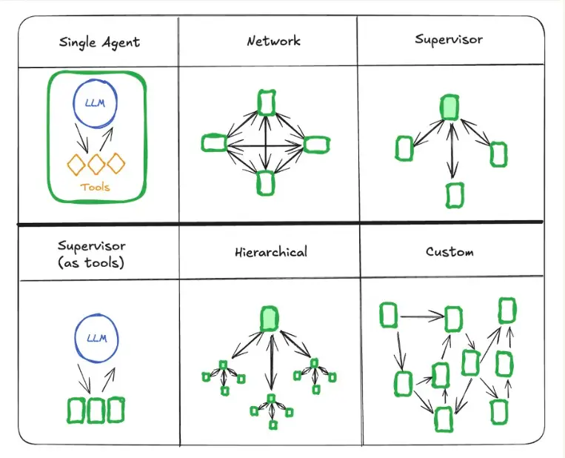
Core Multi-Agent Coordination Patterns
- Orchestrator–Worker (Supervisor / Hierarchical): A central supervisor agent receives the user request, breaks it into subtasks, delegates them to specialized worker/subagents, and aggregates the final results.
  - Best for: Most enterprise production use cases with clear task decomposition.
- Sequential / Pipeline (Chain of Responsibility): Agents run in a linear handoff chain where each agent processes the output of the previous one (e.g., Researcher → Writer → Editor).
  - Best for: Multi-step content creation or step-by-step document processing.
- Parallel / Fan-out–Fan-in (Swarm / Concurrent): The same task or split subtasks are broadcast simultaneously to multiple independent agents, and a reducer/voter aggregates their outputs.
  - Best for: Parallel exploration, vulnerability scanning, or multi-model consensus voting.
- Message Bus / Event-Driven: Agents operate in a decentralized manner by publishing and subscribing to topics on a shared communication layer
Best for: Dynamic systems like security operations where new specialized agents need to plug in without rewiring connections.
- Collaborative / Peer-to-Peer (Mesh): Agents communicate directly with each other as peers, sharing context and debating or refining solutions interactively.
  - Best for: Complex multi-agent reasoning, open-ended research, or generator-verifier feedback loops

